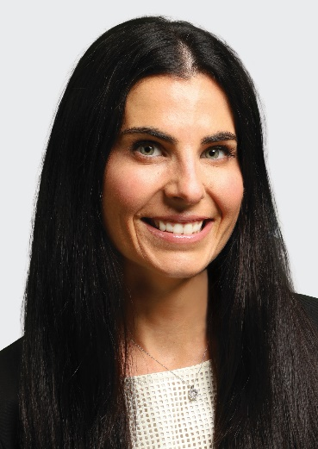
Ali P. Myhre
Associate
Direct: 312.471.8663 Email: amyhre@rshc-law.com
An experienced litigator with a focus on representing clients in the health care, manufacturing, and biotechnology sectors, Ali Myhre handles product liability and mass tort litigation matters nationwide.
Clients value Ali’s academic background in science and bioethics, which has shaped her ability to deftly handle dozens of fact and expert witness depositions in complex disputes, including those involving alleged toxic chemical exposures. Ali is also skilled in legal writing and motion practice and has represented clients in venues across the country.
Dedicated to helping clients develop and execute strategies that manage risk and secure positive outcomes, Ali manages cases through all stages of litigation, demonstrating creative problem-solving and strong analytic skills as well as clear communication and attention to detail.
EXPERIENCE
Representative Engagements
- Representing clients in the manufacturing, biotechnology, and health care sectors in product liability and mass tort litigation at a national level, including advising and implementing strategic initiatives.
Credentials
Education
University of Minnesota Law School, J.D., 2016
Dean’s Honor List
Maynard Pirsig “Best in Brief” Moot Court
University of Miami, B.A., Biology and Psychology, 2013, cum laude
President’s Honor Roll
Dean’s Honor List
Bar Admissions
Illinois
Honors & Awards
Best Lawyers: Ones to Watch (Commercial Litigation and Mass Tort Litigation / Class Actions-Defendants, 2026; Product Liability Litigation-Defendants, 2025-2026), Best Lawyers®
Best Lawyers Women in Law: Ones to Watch (Commercial Litigation and Mass Tort Litigation / Class Actions-Defendants, 2026; Product Liability Litigation-Defendants, 2026), Best Lawyers®

